CLOUD COMPUTING


SUBMITTED TO
SIR WAQAS SALEEM & SIR SHOAIB

SUBMITTED BY
HAMNA MAHMOOD
2023-BSE-025
BSE V-A

Lab 11 – GH CLI Codespaces + AWS + Terraform: Variables, Collections, Sensitivity & EC2 Provisioning

Task 0 Lab Setup (Codespace & GH CLI)
- taskA_codespace_create_and_list.png
- taskA_codespace_ssh_connected.png
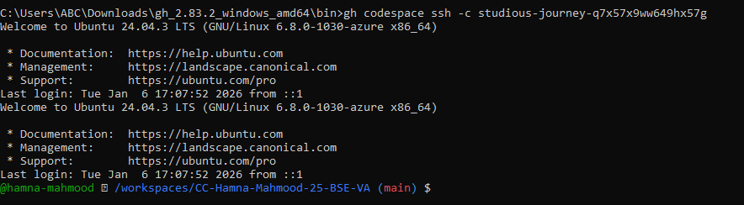
Task 1- Provider & Basic variable
- task1_touch_main_tf.png
- task1_main_tf_provider.png
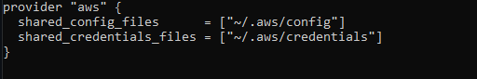
- task1_terraform_init.png
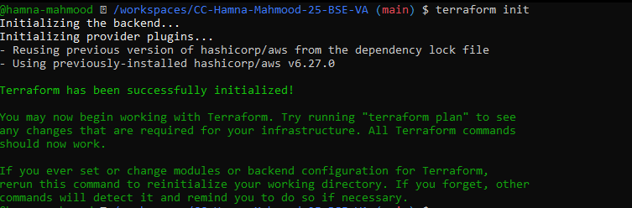
- task1_variable_and_output_added.png
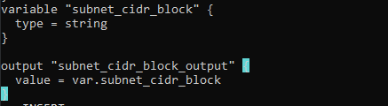
- task1_apply_prompt_for_var.png
- task1_apply_with_default.png
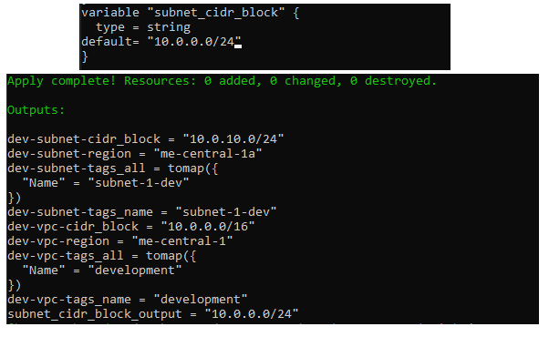
- task1_env_var_set_and_apply.png
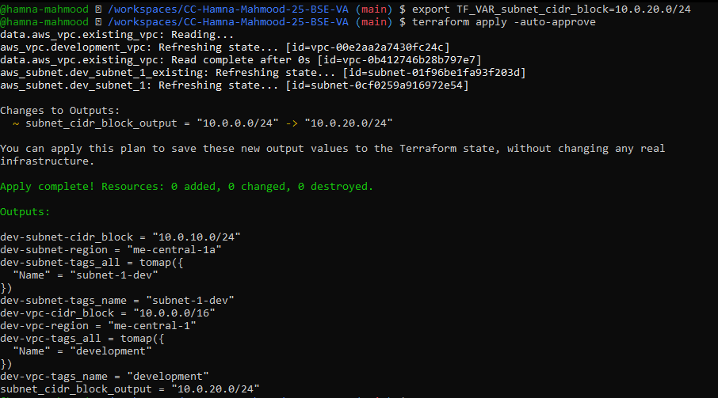
- task1_terraform_tfvars_and_apply.png
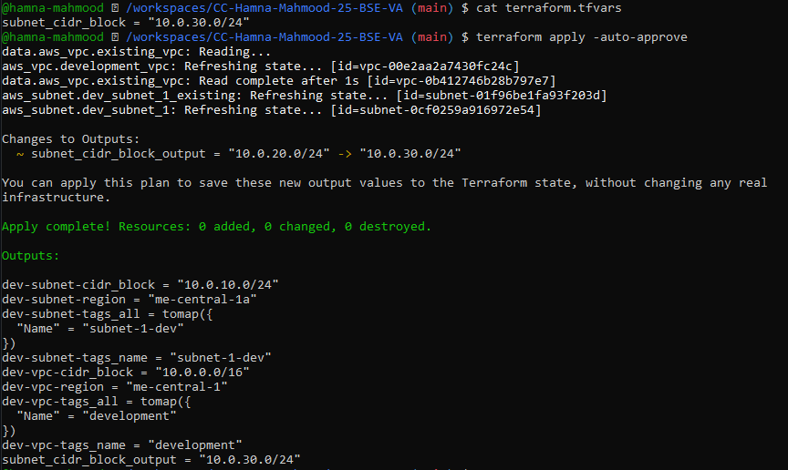
- task1_var_override_with_dash_var.png
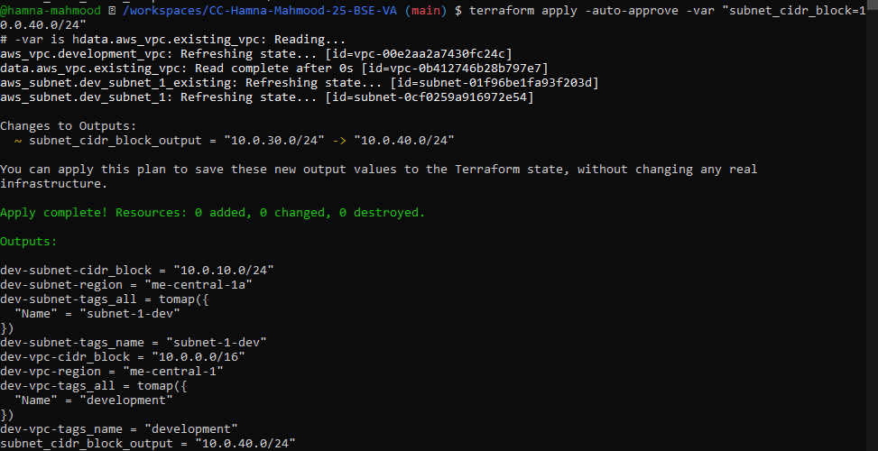
- task1_printenv_tf_var_and_unset.png
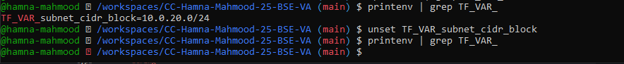

Task 2- Variable validation & sensitive/ephemeral variables
- task2_subnet_variable_with_validation.png
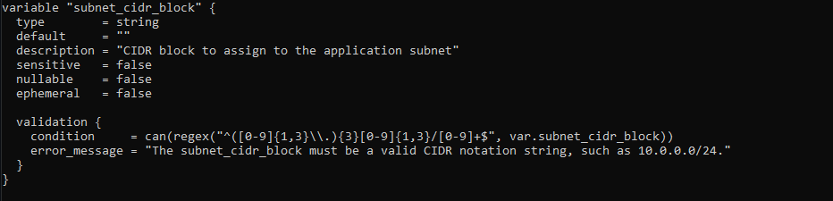
- task2_subnet_validation_error.png
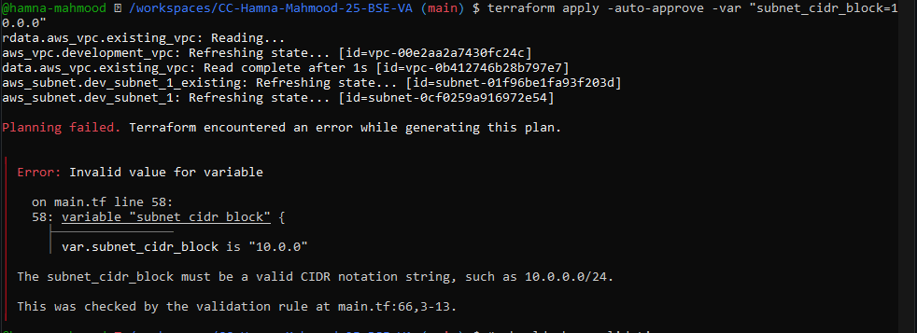
- task2_api_token_variable_added.png
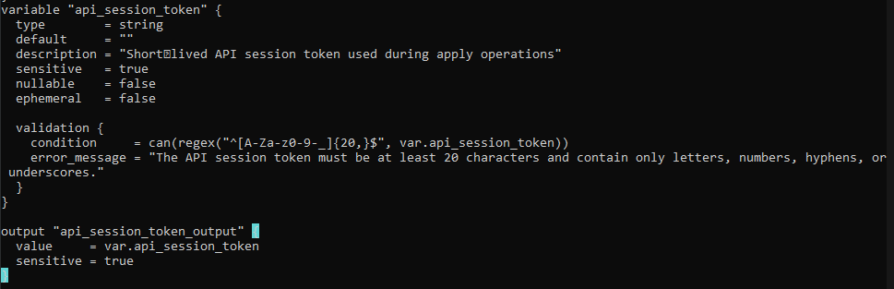
- task2_api_token_apply_sensitive.png
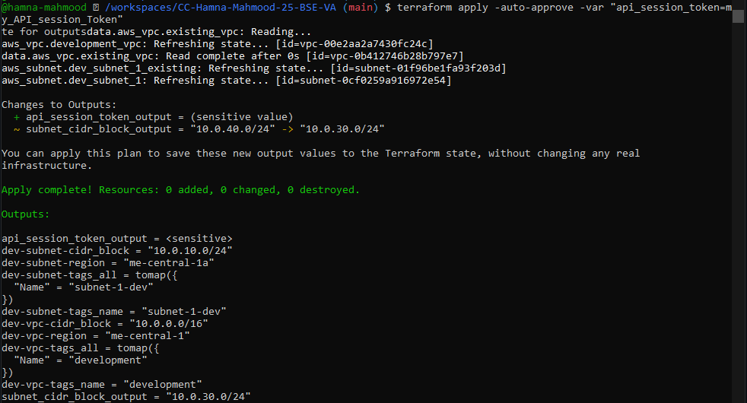
- task2_check_terraform_state_api_token.png
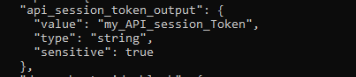
- task2_api_token_ephemeral_error.png
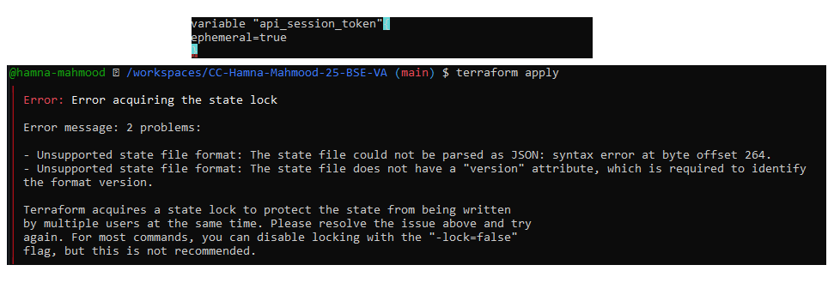
- task2_api_token_default_apply.png
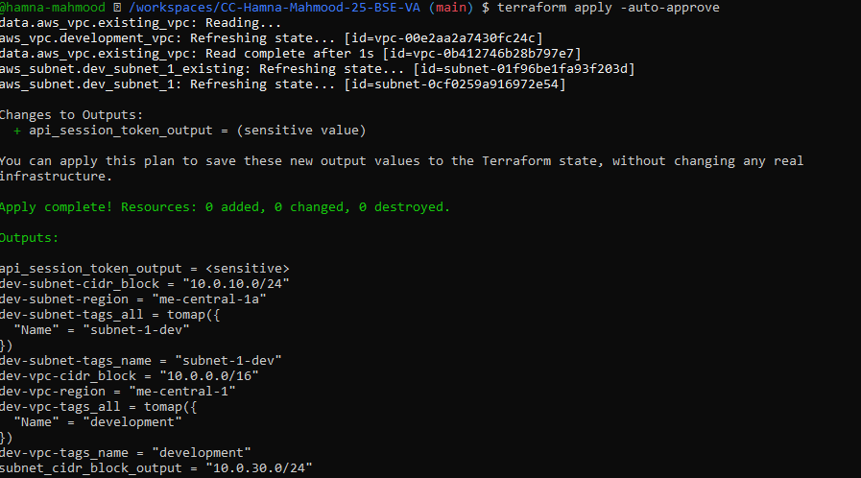
Task3- Project level variables, locals & outputs
- task3_variables_added.png
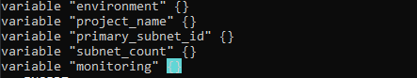
- task3_terraform_tfvars_populated.png
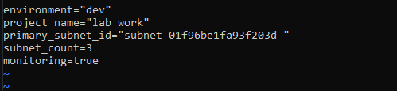
- task3_locals_tf_created.png
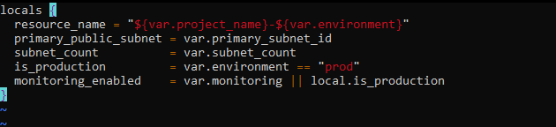

- task3_outputs_apply.png
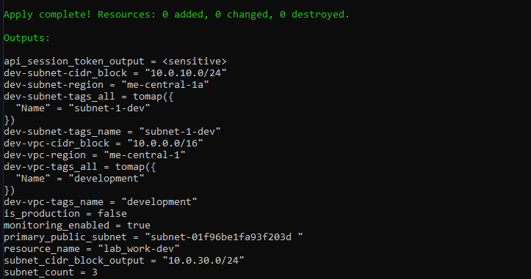
Task 4 — Maps and Objects
- task4_tags_variable_added.png
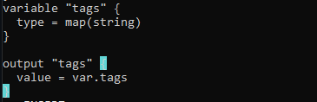
- task4_tags_output.png
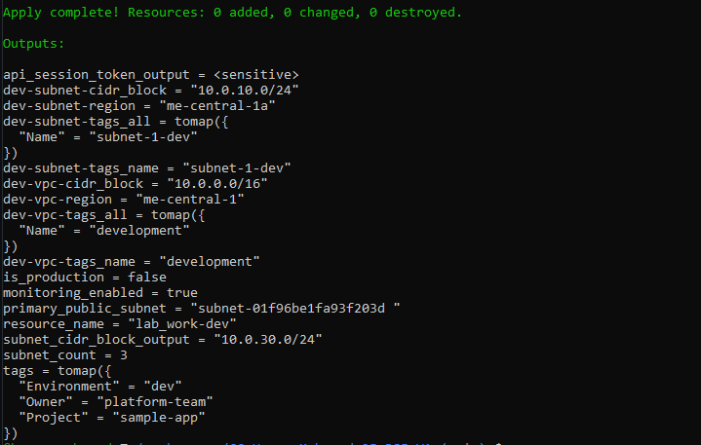
- task4_server_config_output.png
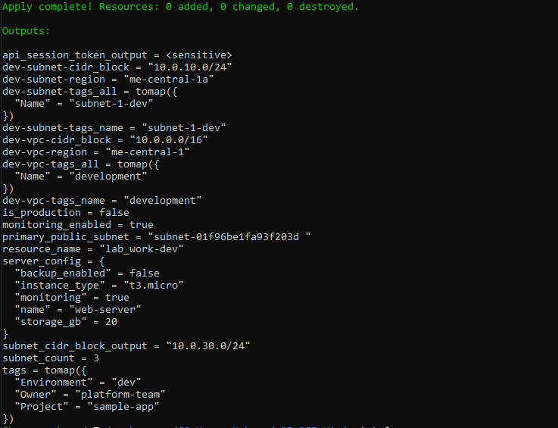
Task 5- Collections: list, tuple, set & mutation via locals
- task5_collections_defined.png
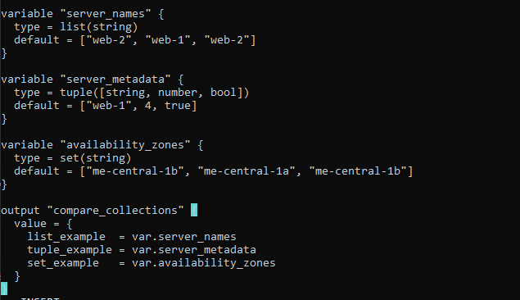

- task5_compare_collections.png
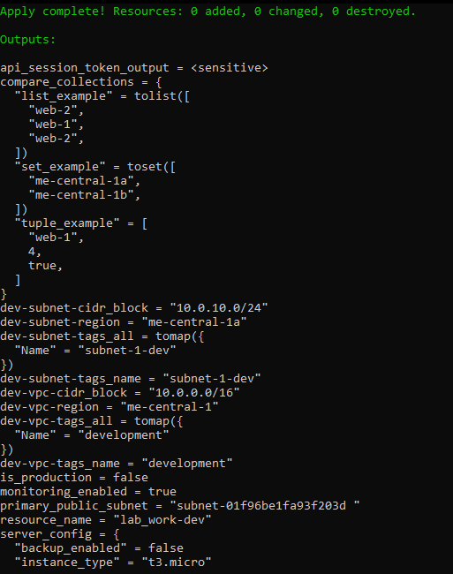
- task5_locals_mutations.png
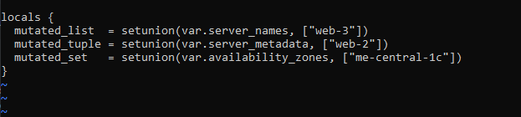
- task5_mutation_comparison.png
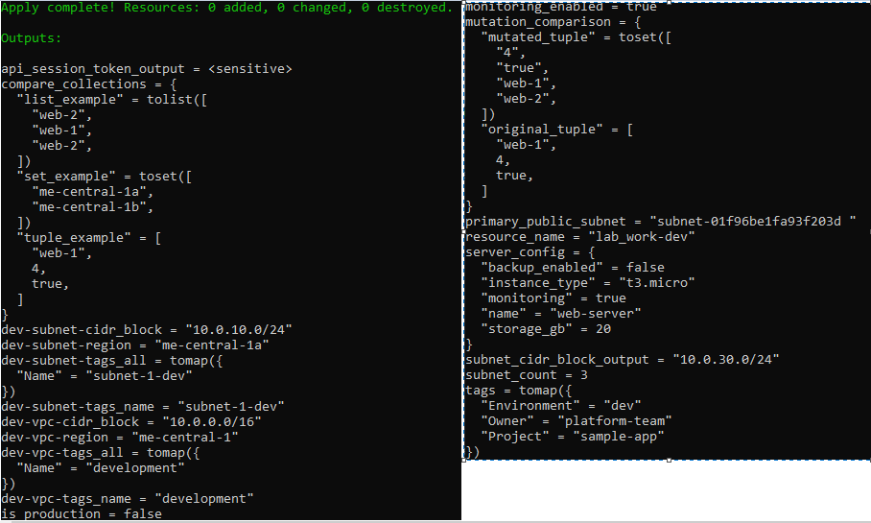
Task 6 — Null, any type & dynamic values
- task6_optional_tag_variable.png
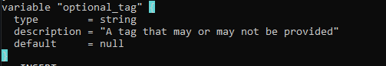
- task6_locals_merge.png
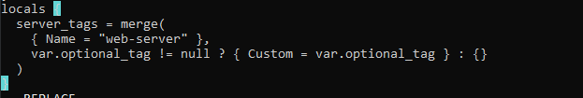
- task6_optional_tag_no_value.png
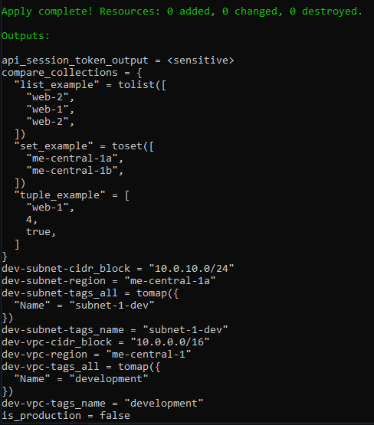
- task6_optional_tag_with_value.png
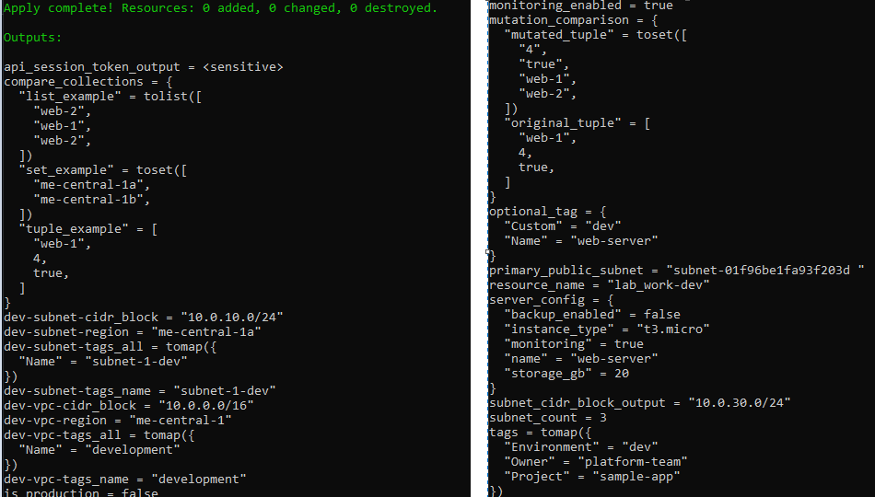

- task6_dynamic_value_string.png
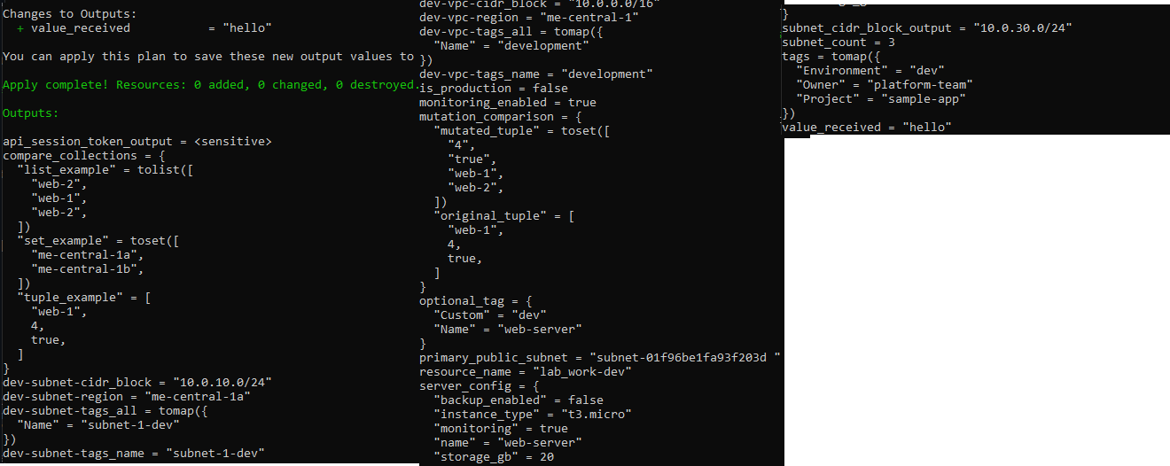
- task6_dynamic_value_number.png
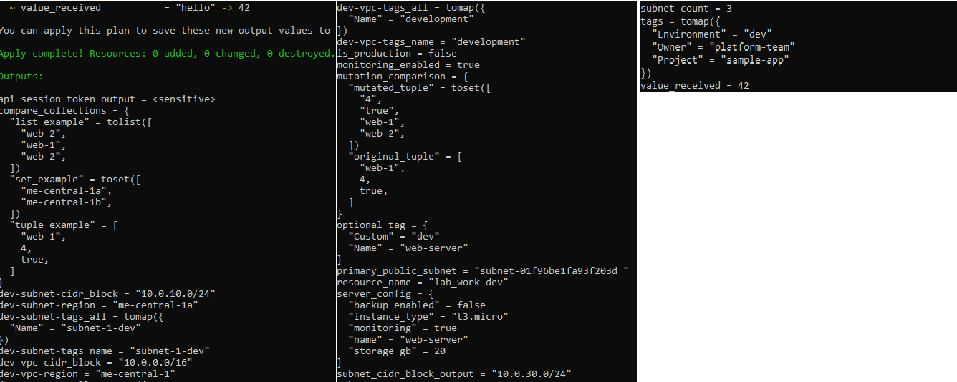
- task6_dynamic_value_list.png
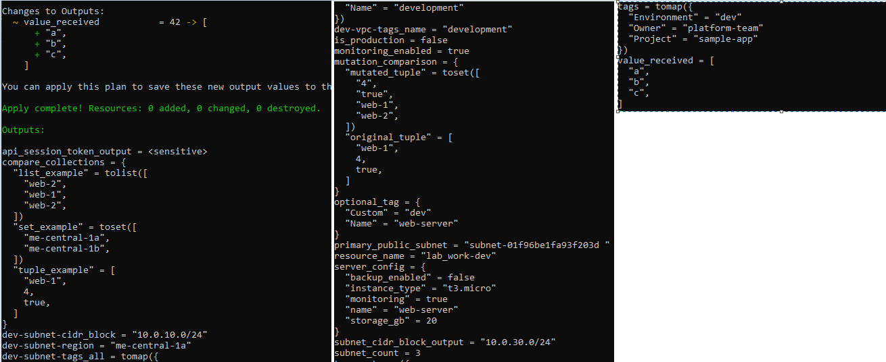
- task6_dynamic_value_map.png
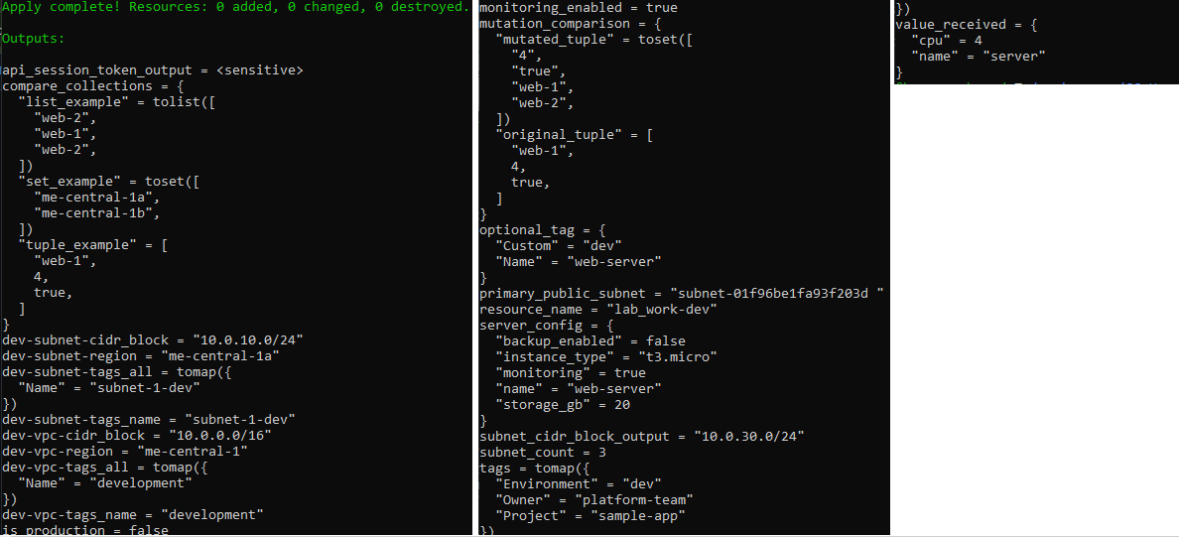
- task6_dynamic_value_null.png
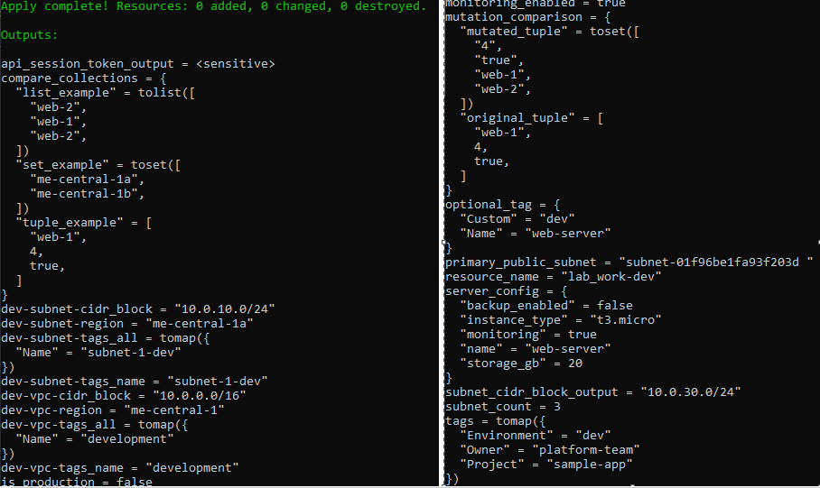

Task 7- Git Ignore
- task7_gitignore_created.png
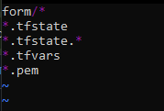
Task 8- Cleanup then build real infra (VPC, Subnet, IGW, routing, default route table)
- task8_clean_files.png
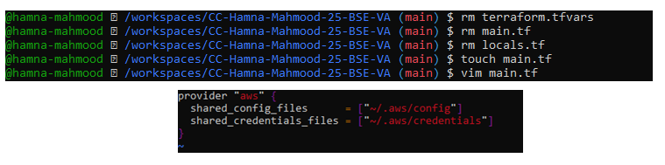
- task8_variables_recreated.png
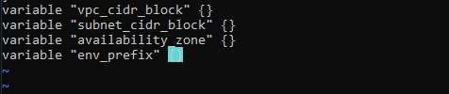
- task8_vpc_resources_added.png
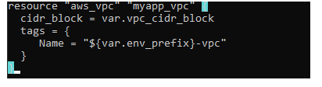
- task8_subnet_resources_added.png
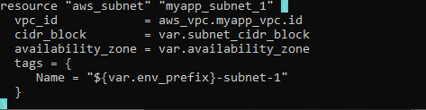
- task8_terraform_tfvars_vpc_values.png
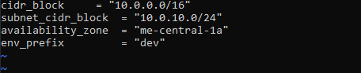
- task8_vpc_subnet_apply.png
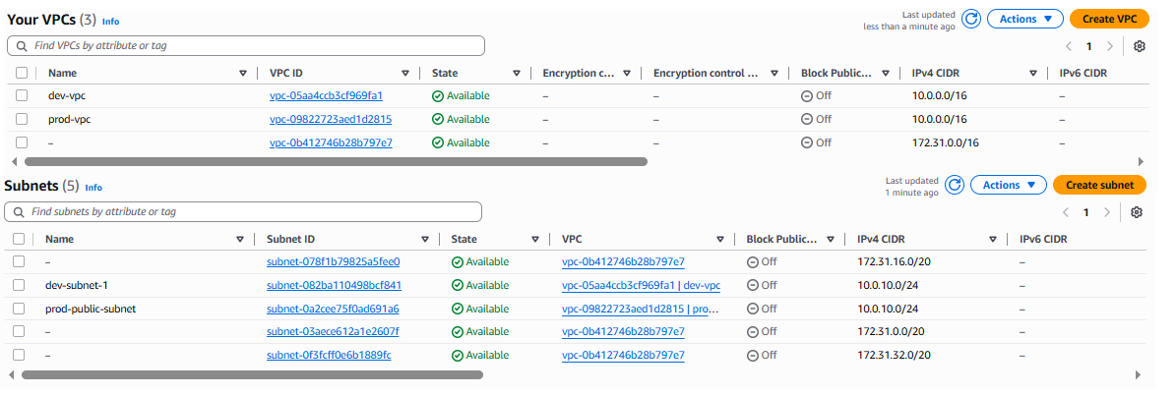
- task8_igw_route_table_before_apply.png
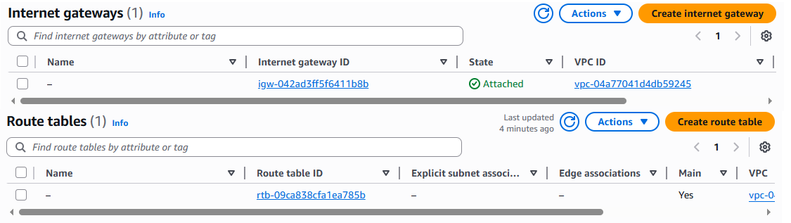
- task8_igw_route_table_after_apply.png
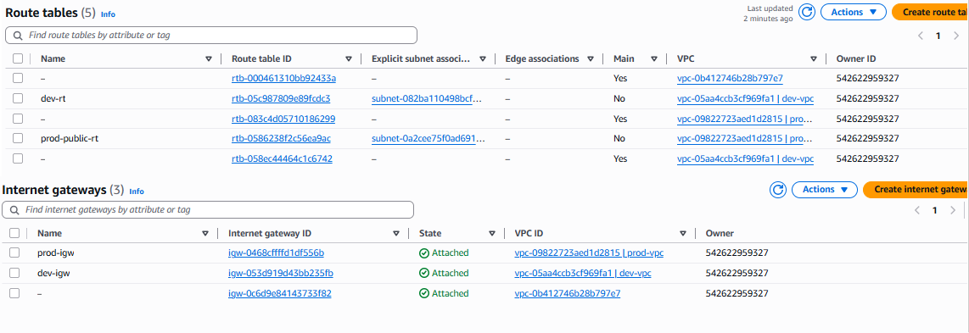
- task8_association_apply.png
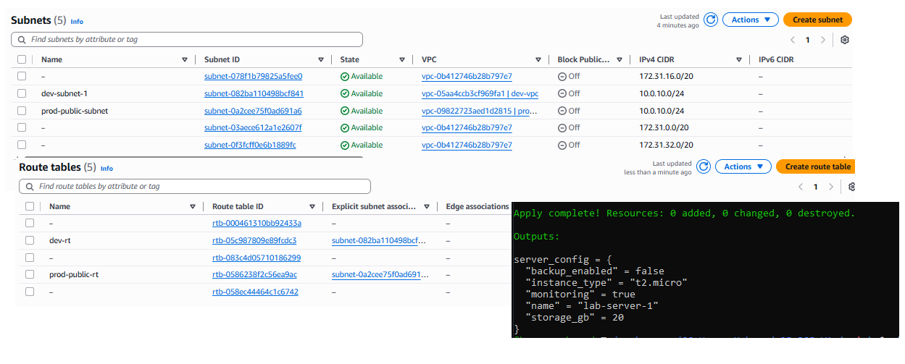
- task8_default_route_table.png
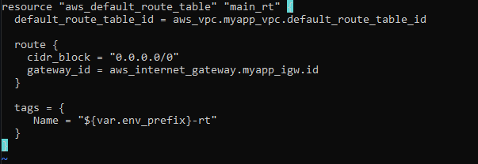
- task8_default_route_table_apply.png
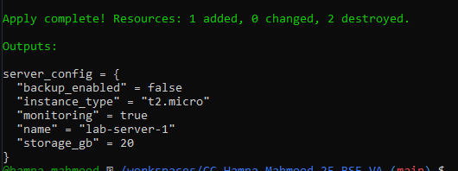
Task 9- Security group, key apir, EC2 instance, user_data & nginx
- task9_my_ip_variable_added.png
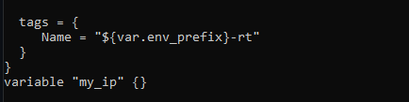
- task9_public_ip_curl.png
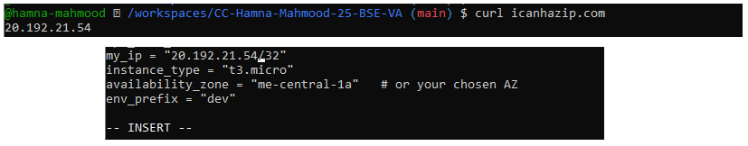
- task9_security_group_apply.png
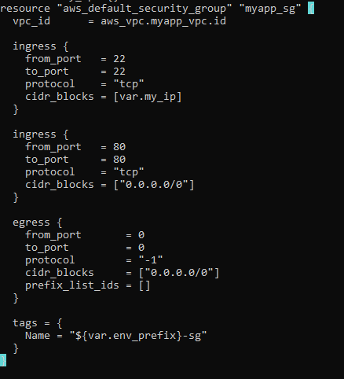
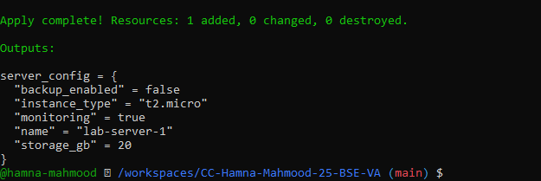
- task9_keypair_created_and_saved.png
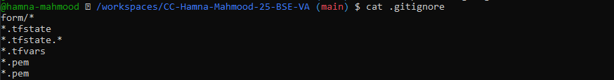

- task9_instance_type_set.png
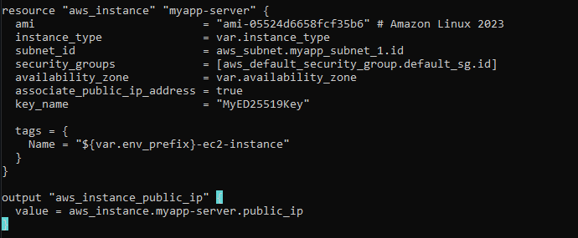
- task9_ec2_apply_and_public_ip.png
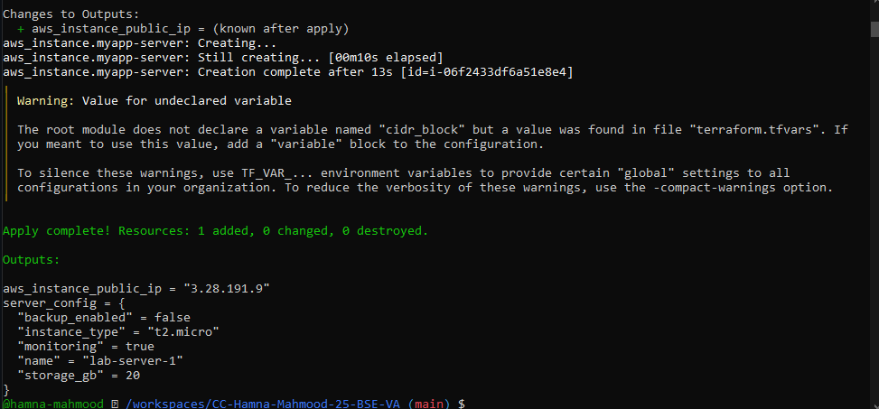
- task9_ssh_into_ec2.png
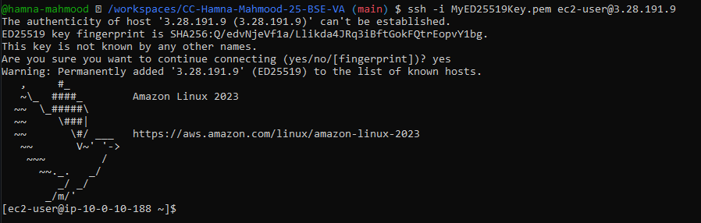
- task9_ssh_keypair_and_ssh.png
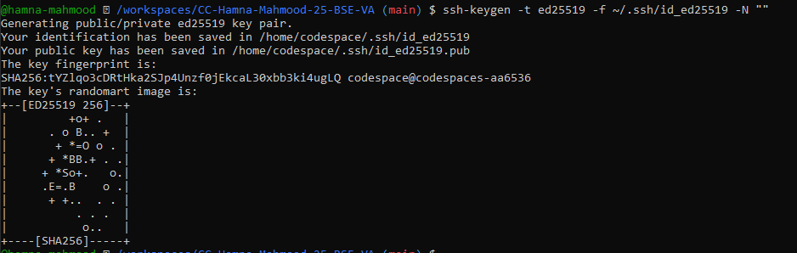
- task9_ssh_keypair_and_shh2.png
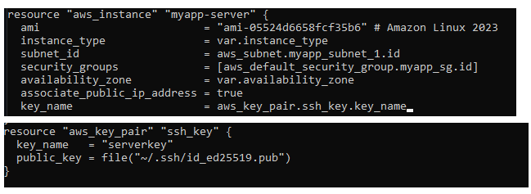
- task9_ec2_apply_and_public_ip
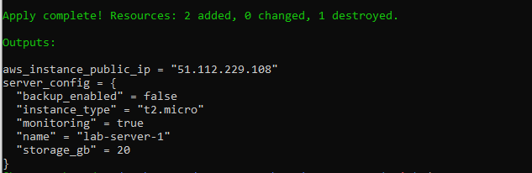
- task9_ssh_keypair_And_ssh3
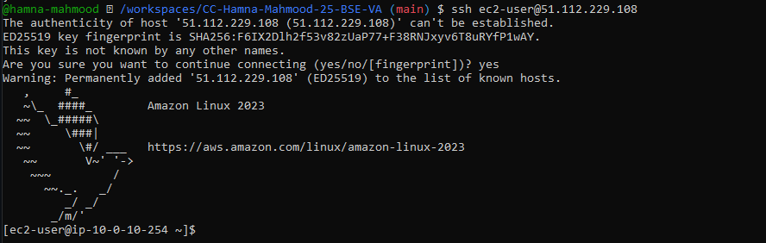

- task9_nginx_local_curl.png
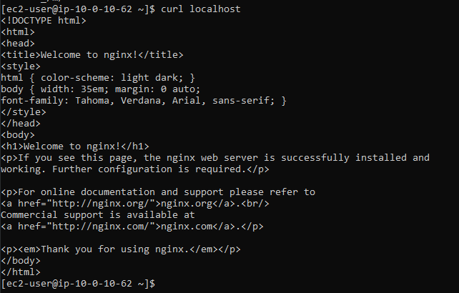
- task9_nginx_browser_page.png
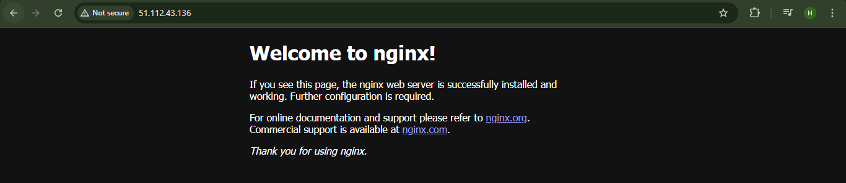
Cleanup
- cleanup_destroy.png
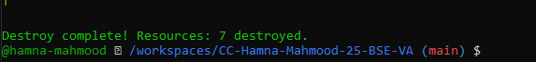
- cleanup_state_files.png
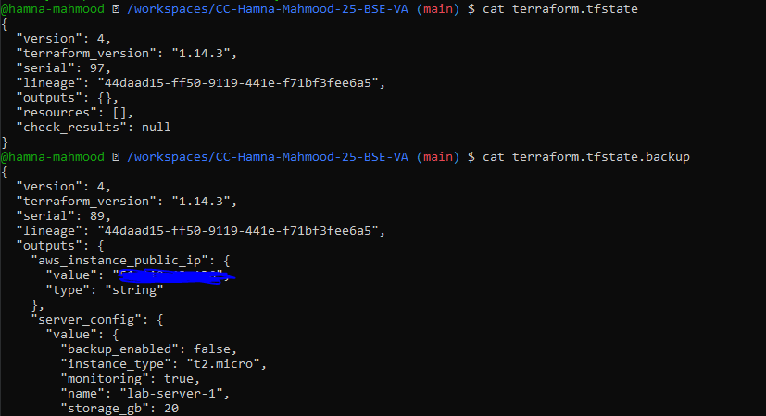
- cleanup_verify_no_secrets.png
